Building a structure takes knowledge, experience,
planning, preparation, and execution.
Project name

PacStates has the knowledge and experience to take you
successfully through the UCaaS journey

Our Mission
“Provide the best combination of Telecommunications and IT solutions based on our client’s definition of success”
Therefore, empowering companies to achieve their highest potential through integrated business technologies, fostering your client’s experience, and your bottom line so that our local community can grow and thrive.

HOW WE DELIVER YOUR UCaaS SOLUTION
PacStates represents leading VoIP providers with a history of excellent implementations. Remember UCaaS (unified Communications as a Service) - this is a phone system. We have found that our management through the implementation process provides you another level of service. Many of our clients also engage us for ongoing customer support above and beyond that from the providers. Our goal is to exceed your expectations and verify you are 100% satisfied with the products, services, and value that PacStates has delivered as your business partner.
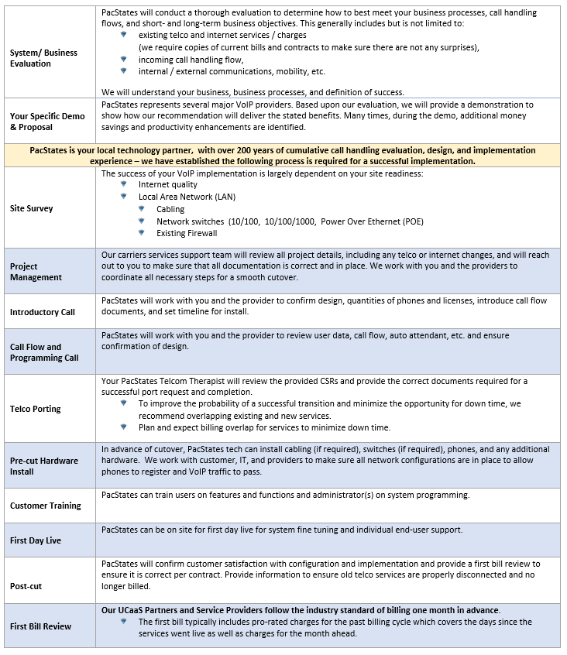
UCaaS (Unified Communications as a Service) may be in the cloud, but remember it is still a phone system that requires multiple layers of details, planning, monitoring, implementation, programming, and trouble shooting. Like a building structure, a successful UCaaS consists of multiple detailed segments.

Pre-Planning
Like you would plan for any structural project:
- What is the goal of the project?
- What is your definition of “success”?
- What is your target completion date?
- Coordination and communication is very important, as an example:
Your UCaaS billing will start once you sign their Agreement. Based on your timeframe, PacStates can request a 30 – 60 day Bill Push if needed.

Building Basics
What are the basics, the foundational requirements that are required to understand and propose the best overall solution, and build a successful project?
- Copies of existing “Phone Services”
  - Phone lines, SIP service, PRI, T-1, etc.
  - Number of Existing phone lines See Telco Worksheet: published numbers, hunt, fire, toll free
- Copies of existing internet services
  - DSL, Coax, Fiber, wireless, etc.
- Existing phone system support agreements,
costs, etc.
- Existing Extensions, Departments See Standard Key Sheet: Name, extension, phone type, email

Architectural Design
What design is required to support stated goals and desired client experience?

- “Call Flow” is required to support:
  - Clients
  - Suppliers
  - Internal

- Departments:

- Automated Attendant
- Direct Inward Dial (DID)
  - DID number range (s)

- Applications? Yes No
  - Voice Mail to Email notification ☐ ☐
  - Operator Position ☐ ☐
  - Desktop App ☐ ☐
  - Mobile App ☐ ☐
  - Softphone ☐ ☐
  - Hunt Groups, ring group ☐ ☐
  - Work from Home / Remote workers ☐ ☐
  - Call Queuing ☐ ☐
    - Basic ☐ ☐
    - Advanced ☐ ☐
    - Voice, Skills based ☐ ☐
      - Multiple groups ☐ ☐
      - Email ☐ ☐
      - Chat ☐ ☐
      - Call back ☐ ☐
  - Audio Conferencing ☐ ☐
  - Web Conferencing ☐ ☐
  - Video Collaboration ☐ ☐
    - Present platform
  - Instant Messaging ☐ ☐
  - Presence ☐ ☐
  - Outlook Integration ☐ ☐
  - Web Dialer ☐ ☐
  - Scribe ☐ ☐
  - Call Recording
    - On Demand ☐ ☐
    - Full Time ☐ ☐
    - Fax Application – email to fax ☐ ☐
  - Analog connections
    - External Paging ☐ ☐
    - Fax Machine ☐ ☐
    - HIPPA requirements ☐ ☐
    - Alarm Line (s)
      - Analog ☐ ☐
      - Cellular ☐ ☐
  - Conference Room requirements
    - Conference Phone ☐ ☐
    - Audio / Visual cabling ☐ ☐
    - Screens ☐ ☐

Infrastructure
Infrastructure is the foundation that supports all your applications and communication structure. As with a building structure, if the foundation is not designed and implemented to support the intended use – it will fail.
Yes No
- Equipment Room in Client Suite ☐ ☐
  - Wall ☐ ☐
  - Rack ☐ ☐
- LAN / WAN for onsite VoIP
  - Firewall ☐ ☐
  - Router ☐ ☐
  - Network Switch – POE ☐ ☐
  - Network Switch - POE ☐ ☐
  - DHCP Server ☐ ☐
  - Network Readiness ☐ ☐
- Cable Infrastructure
  - Cat 5E to each desktop ☐ ☐
  - Cat 6 to each desktop ☐ ☐
  - ☐ ☐

- Existing Desktops
  - PCs ☐ ☐
  - Laptop ☐ ☐
  - W Docking Sta ☐ ☐
  - Apple

- Existing IT Support
  - In-House ☐ ☐
  - Outsourced ☐ ☐
  - ☐ ☐

- Network Readiness ☐ ☐
The VoIP network is tested with industry leading analytics tools, identifying areas of congestion or weakness. A full review of the VoIP Network topology is conducted encompassing routing configurations, firmware versions and over all connectivity to confirm the network meets or exceeds Mitel’s Best Practices. Packet captures and routing equipment logs are analyzed to help identify root cause for VoIP calls or Mitel application issues found
  - Validation both LAN and WAN meeting or exceeding standards ☐ ☐
  - Assurance of clear call services ☐ ☐
  - Peace of mind your foundation is VoIP ready ☐ ☐
  - ☐ ☐

Porting and Cancelation Processes
The process of moving your retained phone number from your existing provider and the new carrier / UCaaS provider. This is a tedious, extremely detailed process that requires hours of reviewing Customer Service Records (CSRs) for applicable numbers.
- Review current carrier bills and create Telco Worksheet
- Execute carrier Letters of Authorization (LOA) to request Customer Service Records (CSRs) from current carriers
- Analyze current carrier contracts and CSRs, make note of expiration dates, auto-renewal clauses
- Document which local and toll-free numbers will port to new service, remain as-is, or be disconnected
- Submit applicable LOAs to initiate port process
- Communicate with carriers on port status, issues, rejections
- Once numbers port to new carrier, provide instructions to disconnect old services no longer in use

Phone System programming information
As with any design project, specific information is required in advance to foster a successful implementation. For your phone system the following information is required:
- Key Sheet:
  - Name
  - Extension, DID
  - Department
  - Email
  - Phone type

- Call Flow
  - How can the system be programmed to efficiently get your caller to the desired party without disrupting the whole office?

System Programming Calls
Based on the information provided and reviewed, your system is ready to program:
- First Call
  - 1-1.5 hours, depending on carrier. May include the following:
    - Review of project scope and introduce carrier and PacStates team
    - Call Flow, phone feature setup, the porting process, review of your phone numbers and invoices from previous providers
    - Scheduling of implementation of the phone system and training for phones, admin portal, and features
    - After call is completed, carrier will email additional required forms and information in preparation for second call (user list, number transfer request, network readiness assessment)
- Second Call
  - Up to 2 hours, depending on carrier. May include the following:
    - Network check (IT consultant or PacStates to be on-site)
    - Programming/Call Flow with carrier system engineer

- Third Call (if required)
  - Up to 1.5 hours, depending on carrier. May include the following:
    - On-site phone and network testing
    - Auto-attendant greetings created and uploaded
    - Confirm Target Go Live date and time prior to submitting port requests

Physical implementation
- Installing required infrastructure
  - Cabling
  - Network devices

- Receiving phones, equipment
  - Deliver on-site
  - Unbox, initiate
- Coordinate porting
  - Transfer of numbers
  - Spoofing
  - Call Forwarding/backup plans
- Test system parameters

End User Training
Good end-user Training is essential to ensuring you gain the efficiencies that were designed with your system, and minimize staff frustration, therefore increasing staff adoption.
PacStates can customize an efficient training program to meet your specific user needs. We have found end user training prior to cutover helps minimize the initial fear of a “new” system. We generally set up training as:
- Small groups onsite
- Individual sessions
- Combination of both

Cutover and first day live
PacStates can be onsite to enhance your initial “Go-Live” experience:
- Assist with answering calls and call handling. Especially with the main answering position(s)
- Make adjustments found during live calls.
Based on the discovery input, we have developed the following timeline that includes your customized Project Checklist and acceptance expectations:
PacStates UCaaS Scope of Work / Acceptance
SOW TASK LIST Target Date Client PSC
- Target Go Live Date Click date

- UCaaS Provider

- IMPORTANT NOTICE:
  - Your UCaaS billing will start once you sign their Agreement. Based on
your timeframe, PacStates can request a 30 – 60 day Bill Push if needed Initial: ____________

Pre-Configuration Information:
- Existing Bill Copy & Term Date - Telco (within last 30 days) Click date ☐
- Existing Bill Copy & Term Date - Internet (within last 30 days) Click date ☐
  - Develop Existing Telco line detail - worksheet Click date
  - Review Telco line detail – worksheet /keep, port, remove Click date
    - Confirm Internet & Telco Expiration Dates Click date
- Extension list with usernames and email (key sheet) Click date ☐ ☐
  - Identify Fax (s) Click date ☐ ☐
  - Identify Alarm Line (s) Click date ☐ ☐
    - Analog, Cellular
  - Conference Room Phone requirements Click date ☐ ☐
  - Identify Internal & External Paging Click date ☐ ☐
  - Any Answering Service Requirements Click date ☐ ☐
  - Phone Type per Profile, (no phone i.e. softphone on desktop) Click date ☐ ☐
- Identify call flow requirements (i.e., Call Center, ATA) Click date ☐
- Identify cable requirements Click date
- Identify Network requirements Click date
  - IT Support Contact Info Click date

Demo and Presentation Based on your Specific Input:
- Demo Click date
- Agreements
  - PacStates UCaaS implementation Click date ☐
  - Internet & Telco Agreements Click date ☐
    - Develop, file, and manage required Letter of Agency(s) (LOA) Click date ☐
  - UCaaS Provider Solution Click date ☐
  - Execute Agreements Click date ☐
  - Execute Applicable Deposits Click date ☐

Implementation:
- Submit, Manage and Track Orders Click date ☐
  - Review and confirm CSRs, Port, keep, and disconnect Click date ☐
  - Manage, confirm and track FOCs Dates (firm Order Commitment) Click date ☐
- Schedule, coordinate and manage 1st Call - Typically 1 – 1.5 Hours Click date
  - Review Order details with Provider
  - Prepare for Call 2
  - Submit Port
  - Confirm & Ship Phones
- Prepare LAN / WAN as identified in pre-field Click date ☐ ☐
  - Cable infrastructure Click date ☐ ☐
  - Network infrastructure Click date ☐ ☐
  - Provide UPS (uninterruptible power supply) Click date ☐

- Schedule, coordinate and manage 2nd Call - Typically 1 – 2 Hours Click date
  - Go over station profile and call flow details
  - Prepare for Call 3
- Schedule, coordinate and manage 3rd Call - Typically 1 Hour Click date
  - Review and test call set up / flow

- Place, unbox, plug in, and initialize phones Click date ☐
- Test system / Phone setup / Voice mail. etc Click date ☐
- Install Desktop & Cell Phone Software Click date ☐ ☐
- Training
  - Train the trainer Click date ☐ ☐
  - Training Classes, typically 3 – 7 per class, 1 hour Click date ☐ ☐
  - UCaaS Provided training Videos Click date ☐ ☐
    - System Administrative (1 Hour) Click date ☐ ☐
    - Adding / removing seats from hunt groups
    - Managing extensions (renaming, re-setting PW)
    - Call Flow (Auto Attendant, hunt groups, Schedules, etc)
- Post Cut-over Support, typically 1 – 3 hours onsite assisting Click date ☐
  - Confirm Call Flow, adjustments if required
  - Assist with Call answering, voice mail, call handling
- Confirm Disconnect Orders Placed Click date ☐
- First Bill Review Click date ☐
- Post Cut Survey Click date ☐

Thorough identification and documentation are crucial when migrating to a new phone system platform. Your PacStates team will assist in identifying and managing your existing Telco phone numbers / services for a successful transition
PacStates Telco Workbook
Existing |  |  | Proposed
Phone Number | Hunt | Dedicated | Keep | Port to Analog | Port to UCaaS | Disconnect | Notes
 | ☐ | ☐ | ☐ | ☐ | ☐ | ☐
 | ☐ | ☐ | ☐ | ☐ | ☐ | ☐
 | ☐ | ☐ | ☐ | ☐ | ☐ | ☐
 | ☐ | ☐ | ☐ | ☐ | ☐ | ☐
 | ☐ | ☐ | ☐ | ☐ | ☐ | ☐
 | ☐ | ☐ | ☐ | ☐ | ☐ | ☐
 | ☐ | ☐ | ☐ | ☐ | ☐ | ☐
 | ☐ | ☐ | ☐ | ☐ | ☐ | ☐
 | ☐ | ☐ | ☐ | ☐ | ☐ | ☐
 | ☐ | ☐ | ☐ | ☐ | ☐ | ☐
 | ☐ | ☐ | ☐ | ☐ | ☐ | ☐
 | ☐ | ☐ | ☐ | ☐ | ☐ | ☐
 | ☐ | ☐ | ☐ | ☐ | ☐ | ☐
 | ☐ | ☐ | ☐ | ☐ | ☐ | ☐
 | ☐ | ☐ | ☐ | ☐ | ☐ | ☐
 | ☐ | ☐ | ☐ | ☐ | ☐ | ☐
 | ☐ | ☐ | ☐ | ☐ | ☐ | ☐
 | ☐ | ☐ | ☐ | ☐ | ☐ | ☐
 | ☐ | ☐ | ☐ | ☐ | ☐ | ☐
 | ☐ | ☐ | ☐ | ☐ | ☐ | ☐
 | ☐ | ☐ | ☐ | ☐ | ☐ | ☐
 | ☐ | ☐ | ☐ | ☐ | ☐ | ☐
 | ☐ | ☐ | ☐ | ☐ | ☐ | ☐
 | ☐ | ☐ | ☐ | ☐ | ☐ | ☐
 | ☐ | ☐ | ☐ | ☐ | ☐ | ☐
 | ☐ | ☐ | ☐ | ☐ | ☐ | ☐
 | ☐ | ☐ | ☐ | ☐ | ☐ | ☐

PacStates will assist you in creating the following documentation for your new phone system. This is derived from your exisitng personel and extension list. All of this information will be reuired to ensue all stations are identified and the correct number and type of profiles / phones are planned for:
PacStates UCaaS "Key Sheet"
First Name | Last Name | DID # | Ext # | Deprt | Telephone / Ext Type |  |  |  | Profile / License type |  |  | Email Address
 |  |  |  |  |  |  |  | Analog
Analog Fax Machine
External Paging Port / zones
 |  |  |  |  | 0 | 0 | 0 | 0 | 0 | 0 | 0

